**Result 1: Global analysis**

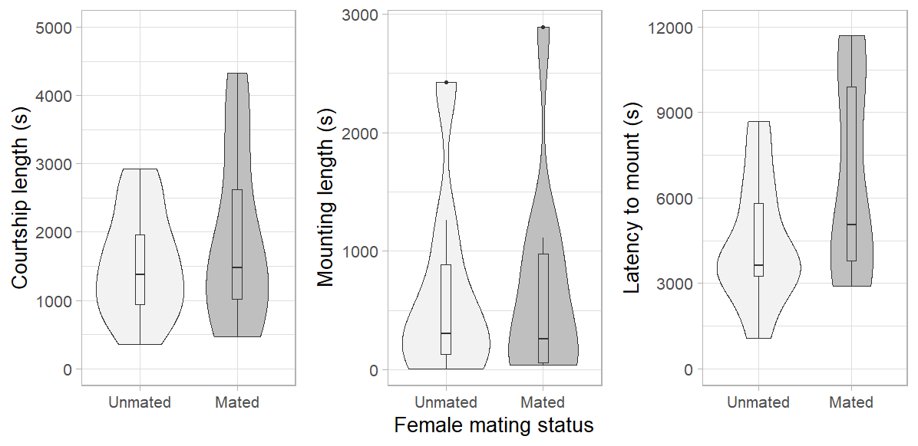

**Figure 1.** Comparison of male first reproductive attempt parameters in *Dolomedes minor* between trials with unmated and already mated female, with (a) total duration of first courtship segment, (b) total duration of first mounting behaviour (included in a) and (c) latency to mount the female. Plots represent the density distribution of the variable as well as the median and the interquartile and 1.5x interquartile range. There were no significant differences for any of those parameters on Wilcoxon signed-rank test.

**Results 2: Female aggressiveness**

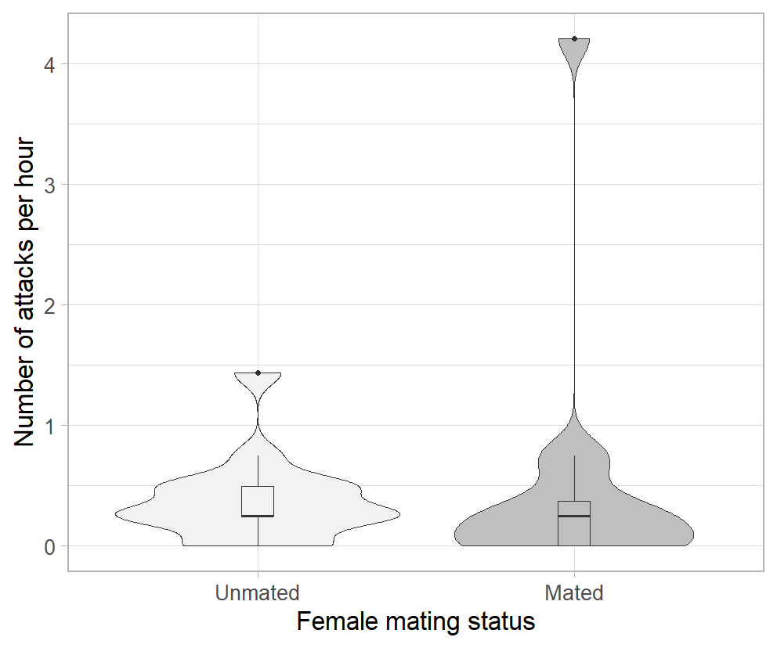

**Figure 2.** Comparison of the number of female attacks towards male per hour between trials with unmated and already mated females. Plots represent the density distribution of the variable as well as the median and the interquartile and 1.5x interquartile range. There were no significant differences for any of those parameters for Wilcoxon signed-rank test. There were no significant differences between the two groups on Wilcoxon signed-rank test.

**Table 1.** Ethogram of male courtship behaviours in *Dolomedes minor*.

|  |  |  |  |
| --- | --- | --- | --- |
|  |  | **Behaviour** | **Description** |
|  |  |  |  |
| Leg Display |  | Leg Raise | Raising of one or more of the legs, straight or slightly bent, at an angle between 50 and 90°, for at least one second without performing any specific aerial pattern with the tarsus or the rest of the leg. Behaviour ends when the leg is lowered and touches the substrate or a specific vibrational pattern is drawn with the tarsus or the whole leg (See Wave and Aerial Tremulation). |
|  | Wave | Raising of one or more of the legs, straight or slightly bent, a performing several circular or vertical fluid aerial movements with the whole leg and tarsus. Vertical movements can be performed between on a 90° angle. Behaviour ends when the leg has stopped moving for more than one second (see Leg Raise) or is lowered to touch the substrate. |
|  | Aerial Tremulation | Raising of one more of the front legs, slightly bent, performing quick and repeated vertical movements with the whole leg, freely in the air or by grabbing a female silk dragline with the tarsus in some cases. Behaviour ends when the leg has stopped moving for more than one second (see Leg Raise) or is lowered to touch the substrate. |
|  | Wipe | Following Leg Raise, Wave or Aerial Tremulation behaviours, instead of simply touching the substrate, the individual is lowering its leg straight on the site of its body and is wiping the substrate with its tarsus, always towards its cephalothorax. It is often followed by Quick Tapping. |
|  | Quick Tapping | Extension forward of one or more of the front legs with a quick tapping of the tarsus on the substrate or the female silk dragline. Sometimes performed on female legs when the male is close to a mounting attempt. |
|  | Leg Rubbing | While mounting the female, legs are bent and perform quick vertical and horizontal repeated movements. Often associated with a repositioning of the male on the female and approaching of the pedipalps towards the female genitalia. It is the only leg behaviour performed during mounting. |
|  |  | Pedipalp Display | Quick vertical and repeated movement of both pedipalps in the air, sometimes while grabbing a female silk dragline. |
|  |  | Body Surge | Sudden tap of the abdomen on the substrate with contraction of the whole body. Often paired with an abrupt tap of some of the legs on the substrate, especially when they are already raised. |
|  |  | Abdominal Tremulation | Repeated quick horizontal vibration of the abdomen performed without touching the substrate. Abdomen is mainly remaining aligned with the rest of the body. |
|  |  | Grooming | Brushing of the pedipalps, legs and chelicerae together, sometimes only two of them. |
|  |  | Approach | Locomotion towards the female accompanied by clear courtship signals. |
|  |  | Retreat | Quick moving away from the female in response to a clear signal from her such as a vibration, a movement or an attack. Behaviour can be triggered when the male is mounting the female, always leading to the end of Mount behaviour. |
|  |  | Mount | Male climbs onto the female’s abdomen. |
|  |  | Pedipalp Insertion | Extension of one pedipalp toward the genitalia of the female which leads to embolus insertion and successful copulation. |